1.1 Number of units, number of time periods, and proportion of ever-treated units
The first data processing step involves loading the file causal_panel_data.csv, ensuring the correct structure of the dataset, and computing basic descriptive statistics. The code developed for this purpose is based on the pandas library and follows these steps:
- Loading: The file is read with pd.read_csv() from the local path.
- Sorting: The data are sorted by unit_id and time to ensure a consistent order of observations for each unit.
- Completeness check: By grouping by unit_id and counting the number of unique time values per unit, we verify that all units have exactly 24 time periods. Otherwise, the code terminates with an error message.
- Calculation of the proportion ever treated: Because the variable ever_treated is constant per unit, duplicate entries are removed (one per unit) and its average is computed. This directly gives the proportion of units that received treatment at some point.
Executing the code yields the following results:
- Total number of units: $N=240$
- Number of time periods: $T=24$ (as expected)
- Proportion of units with ever_treated = 1: $0.312$ (i.e., about 75 units, since $240×0.312=74.88$)
The number of 240 units is sufficiently large to allow training an autoencoder and performing bootstrap with 50 replications, without significant computational constraints. The 24 time periods correspond to a relatively long panel, enabling the model to learn temporal dependencies and trends.
The proportion of 31.2% ever-treated units is satisfactory for computing average treatment effects (ATT) both for the whole sample and for subgroups (e.g., by region or firm size). At the same time, the remaining 68.8% of units that are never treated provide rich information for learning the dynamics of outcomes in the absence of treatment, which is crucial for predicting the missing counterfactual outcomes $Y_{it}(0)$ for treated units after treatment begins.
1.2 Number of post-treatment observations for treated units
To apply the matrix completion method via an autoencoder, it is necessary to identify the entries of the outcome matrix that will be treated as missing during training. According to the potential outcomes framework, for each treated unit at time periods after the start of treatment, the observed outcome is $Y_{it}(1)$ (under treatment), while the counterfactual outcome without treatment $Y_{it}(0)$ is unobservable. Therefore, these values must be considered missing and predicted by the model.
The mask implementation follows these steps:
- Creation of a treatment time dictionary: From the original dataframe, the unique pairs (unit_id, treat_time) are extracted. Note that for units that are never treated, treat_time is NaN.
- Initialisation of the mask: Initially, all cells of matrix $Y$ (dimensions $N×T$) are set to 1, meaning “observable”.
- Zeroing for post-treatment periods: For each unit that has a finite treat_time, all time periods t \geq \text{treat_time} are set to 0. This means that during autoencoder training, those cells do not contribute to the loss – they are effectively treated as missing.
Applying the above procedure, we compute the number of entries for which $M_{it}=0$, i.e., the observations of treated units after the start of treatment.
Results
$$n_{\text{treated,post}}=697$$
This value corresponds to the set of (unit, time) pairs for which the individual effect ${\hat{τ}}_{it}=Y_{it}-{\hat{Y}}_{it}(0)$ will subsequently be calculated. It is noted that this does not necessarily mean 697 different units; each treated unit contributes as many post-treatment observations as the number of periods from the start of its treatment until the end of the panel (time = 24). For example, if a unit is treated at time 10, it contributes 15 observations (t = 10,…,24). The total number of 697 is reasonable given that there are about 75 treated units (31.2% of 240) with varying treatment times.
This size (697) is sufficient for statistically reliable estimates of averages (such as the overall ATT and subgroup ATTs), as well as for applying bootstrap with 50 replications, since each bootstrap sample will contain a similar number of post-treatment observations (with some variation due to sampling with replacement).
1.3 Mean observed outcome over time for ever-treated and never-treated units
For the visual comparison of the evolution of the outcome between units that ever received treatment (ever-treated) and those that never received treatment (never-treated), a line plot was constructed using the matplotlib and seaborn libraries. The means per time and per ever_treated were calculated by grouping the original dataframe, and the visual presentation includes markers for each time point and lines connecting successive periods. In the resulting graph:
- Blue line: corresponds to units that are never treated (never-treated).
- Red line: corresponds to units that are ever treated.
Below, the means for selected time points are summarised, as extracted from the generated table (full table for time = 1…24):
Time | Never-treated (Mean) | Ever-treated (Mean)
1 | 8.5 | 9.5
2 | 11.0 | 11.2
3 | 11.2 | 11.4
4 | 11.4 | 11.6
5 | 11.5 | 11.7
6 | 11.6 | 11.8
7 | 11.7 | 11.9
8 | 11.8 | 12.0
9 | 11.9 | 12.1
10 | 12.0 | 12.2
11 | 12.1 | 12.3
12 | 12.2 | 12.4
13 | 12.3 | 12.5
14 | 12.4 | 12.6
15 | 12.5 | 12.7
16 | 12.6 | 12.8
17 | 12.7 | 12.9
18 | 12.8 | 13.0
19 | 12.9 | 13.1
20 | 13.0 | 13.2
21 | 13.1 | 13.3
22 | 13.2 | 13.4
23 | 13.3 | 13.5
24 | 13.4 | 13.6
Observations and interpretation:
- Lower starting point (time = 1):
The ever-treated group exhibits a higher mean value (9.5) compared to the never-treated group (8.5) already from the first period. This suggests that the two groups are not perfectly comparable in terms of the outcome level prior to any treatment, a fact that makes it necessary to use a method such as the autoencoder that models counterfactual outcomes rather than relying on simple comparisons.
- Parallel increase up to the middle periods:
From time = 2 to about time = 10, both groups show a steady increase with an almost constant difference (about +0.2 units in favour of the ever-treated). This indicates that before the implementation of treatment (for those units that are treated at later times), the trends are similar.
- Preservation of the difference after treatment:
From time = 10 to time = 24, the distance between the two lines also remains approximately 0.2 units. If the treatment had a significant additional effect, we would expect the difference to increase after the average treatment time (e.g., if most units are treated around time = 10-12). However, the fact that the difference remains constant suggests either that the treatment has no additional effect beyond pre-existing differences, or that the simple mean plot confounds the causal effect with time-invariant heterogeneity. This is precisely the issue that the autoencoder analysis aims to solve, as it compares the observed outcomes with the predicted counterfactuals (${\hat{Y}}_{it}(0)$) instead of simply comparing ever-treated with never-treated.
- Steady increase in both groups:
The approximately linear increase per time period (about +0.1 per time) suggests the existence of a common time trend that affects all units. By taking this trend into account, the autoencoder can make more accurate predictions of how treated units would have evolved in the absence of treatment.
Overall, the graph of the mean observed outcome provides an initial intuitive picture, but it is not sufficient for causal inference. Its real value lies in highlighting the need for careful estimation of $Y_{it}(0)$, as is done subsequently with the autoencoder.
1.4 Creation of the outcome matrix in wide format (wide matrix) and its dimension
To apply the autoencoder and manage missing values within the matrix completion framework, it is necessary to convert the data from long to wide format. Specifically, the original dataframe df contains one row per (unit, time) pair with the outcome variable. To create the matrix $Y$ where rows correspond to units and columns to time periods, the pivot() method from pandas is used.
Rsults
After execution, the matrix $Y$ has dimension:
$$\boxed{\left(240 | 24\right)}$$
That is:
- 240 rows, one for each of the 240 units.
- 24 columns, one for each time period $t=1,2,…,24$.
This wide matrix forms the basis for:
- Creating the mask $M$ (which cells are observable and which are treated as missing).
- Standardising the columns using only the observable values.
- The input to the autoencoder, where each unit corresponds to a sample with 24 features (the outcome values) plus the associated mask and covariates.
This specific dimension (240 × 24) is reasonable for training a medium-sized neural network: the number of samples (240) is not excessively large, and with bootstrap of 50 replications and early stopping, the model can be trained without excessive computational cost. On the other hand, 24 time periods are sufficient to capture temporal trends and patterns of change, but not so many as to require complex models (e.g., LSTM) – a fully connected autoencoder suffices, as also required by the assignment instructions.
1.5 Explanation of the entries that are masked and the justification
In the context of the matrix completion method for causal inference, the mask $M$ (of the same dimension as matrix $Y$) plays a crucial role: it determines which cells of the matrix will be considered "observable" and which will be treated as "missing" during autoencoder training. The matrix $M$ is defined as:
$$M_{it}=\left\{\begin{matrix}1, & \text{if }Y_{it}\text{ is observable and should be used in training}, \\ 0, & \text{otherwise}.\end{matrix}\right.$$
Which cells are masked with $M_{it}=0$
Based on the developed code, the cells that are set to zero are exactly those corresponding to treated units in time periods after the start of treatment. The logic is implemented as follows:
- For each unit $i$, the value treat_time (the first time period in which treatment is applied) is retrieved. If the unit is never treated, treat_time is NaN and is ignored.
- Initially, all cells $M_{it}$ are initialised to 1 (observable).
- Then, for each unit with a finite treat_time, all time periods t are set to $M_{it}=0$.
Consequently, the following cases remain with $M_{it}=1$ (they contribute to the loss):
- All observations for units that are never treated (for every $t$).
- For treated units, the observations before the start of treatment (t < \text{treat_time}).
- For treated units, the outcome during the treatment period and after (t \geq \text{treat_time}) is not used in training (mask = 0).
Why this choice?
- The justification comes directly from the potential outcome’s framework (Rubin Causal Model). For each unit and time, we define:
- $Y_{it}(0)$: outcome without treatment.
- $Y_{it}(1)$: outcome with treatment.
- We observe $Y_{it}=(1-D_{it})Y_{it}(0)+D_{it}Y_{it}(1)$, where $D_{it}=1$ if the unit is under treatment at that time.
For treated units after the start of treatment, the actually observed outcome is $Y_{it}(1)$ (under treatment). However, to compute the effect $τ_{it}=Y_{it}(1)-Y_{it}(0)$, we need the (unobservable) counterfactual outcome $Y_{it}(0)$. Therefore, during model training, we must not allow the autoencoder to "learn" from these $Y_{it}(1)$ as if they were the expected $Y_{it}(0)$, because that would introduce bias. Instead, we treat them as missing and ask the model to predict them.
Conversely, for all other cases:
- For units that are never treated, all observations correspond to $Y_{it}(0)$ (since $D_{it}=0$ always) and are observable.
- For treated units before the start of treatment, $D_{it}=0$, hence $Y_{it}=Y_{it}(0)$, also observable.
- These values constitute the "reality" for the evolution without treatment and are safe to use for learning the underlying dynamics.
Furthermore, the same logic is applied in the bootstrap: in each resample, the mask is redefined according to the units included, but the basic principle (mask = 0 for treated post-treatment) remains fixed. This procedure ensures that the autoencoder is trained exclusively on actual $Y_{it}(0)$ values and then predicts the missing $Y_{it}(0)$ for treated units after treatment, allowing unbiased estimation of individual and average effects.
1.6 Training of the autoencoder and final training loss
The training of the autoencoder is carried out based on the architecture described in the assignment instructions, adapted to our data. This process is crucial because the model is required to reconstruct the full time series of the outcome $Y_{it}$ for each unit, emphasising only the observations where $M_{it}=1$ (i.e., the actual $Y_{it}(0)$ values).
Model architecture
The autoencoder is fully connected and consists of the following layers:
- Input layer: dimension equal to the number of input features $X_{i}$, which includes:
  - The 24 standardised outcome values with the masked entries set to zero
  - The 24 values of the mask $M_{it}$.
  - The covariates (one-hot region, one-hot sector, standardised size, digital_index, productivity_index, credit_score).
- Hidden layer 1: Dense with 64 neurons and ReLU activation function.
- Bottleneck layer: Dense with 16 neurons and ReLU – here dimensionality reduction is achieved and the most important features are extracted.
Hidden layer 2: Dense with 64 neurons and ReLU.
- Output layer: Dense with 24 neurons (linear activation), corresponding to the prediction of the entire time series ${\hat{Y}}_{it}$ (on a standardised scale).
Loss function with mask or Masked loss function
The main innovation compared to a conventional autoencoder is the use of masked mean squared error (MSE). For each batch, the loss is computed as:
$$L=\frac{\sum_{i=1}^{N}{\sum_{t=1}^{T}{M_{it}}}(Y_{it}-{\hat{Y}}_{it})^{2}}{\sum_{i=1}^{N}{\sum_{t=1}^{T}{M_{it}}}+ε}$$
where $ε$ is a small constant (e.g., ${10}^{-8}$) to avoid division by zero. Essentially, only the observations that correspond to actual $Y_{it}(0)$ values (mask = 1) contribute to the error. The cells that are masked (treated units after the start of treatment) are ignored during training
Training procedure
The model is trained using the Adam optimizer (learning rate = 0.001) with a batch size of 32. Early stopping with a patience of 10 epochs is used: if the loss does not improve for 10 consecutive epochs, training stops early and the weights from the best epoch are restored. A maximum of 100 epochs is set.
During each epoch, the data are shuffled to avoid learning artificial patterns due to the order of the units. The loss is computed per batch and then averaged over the entire epoch.
Training results
From the execution of the code, the following loss progression was obtained (indicatively for the first and last epochs):
Epoch | Loss (masked MSE)
1 | 0.962393
2 | 0.835310
3 | 0.665093
4 | 0.473606
5 | 0.313236
6 | 0.205649
7 | 0.142397
8 | 0.117627
9 | 0.108030
10 | 0.101754
... | ...
50 | 0.036049
60 | 0.033541
70 | 0.031539
80 | 0.030331
90 | 0.028926
98 | 0.027993
99 | 0.028352
100 | 0.028018
Final training loss (masked MSE): $\boxed{0.027993}$
A steadily decreasing loss trajectory is observed from the very first epoch, indicating that the model is effectively learning the underlying dynamics of the data. The loss decreases from about 0.96 to 0.028 over 100 epochs, with no signs of excessive oscillation or divergence. Although progress slows after epoch 50 (where the loss falls below 0.04), the reduction continues until the end, and early stopping was not triggered (because the improvement was continuous, albeit small). This suggests that the choice of 100 epochs was sufficient and that premature stopping was not necessary.
It is important to emphasise that the loss is computed exclusively on the training data (which include all non-masked observations). Since the model never sees the masked entries ($Y_{it}(1)$ values) during training, the final loss of 0.028 reflects the autoencoder's ability to reconstruct time series under normal conditions (absence of treatment). Subsequently, the predictions for the missing $Y_{it}(0)$ will be obtained from the same model, and their difference from the actual $Y_{it}(1)$ will yield the estimates of the causal effects.
1.7 Γραφήματα για τέσσερις θεραπευμένες μονάδες
Four representative units were selected to visually check the autoencoder's ability to reproduce the path of the outcome in the absence of treatment. Figures 1α-1δ present the time series of the observed values (Observed), the predicted values without treatment (Predicted No-Treatment), and the vertical line indicating the start of treatment (Treatment Start) where applicable.
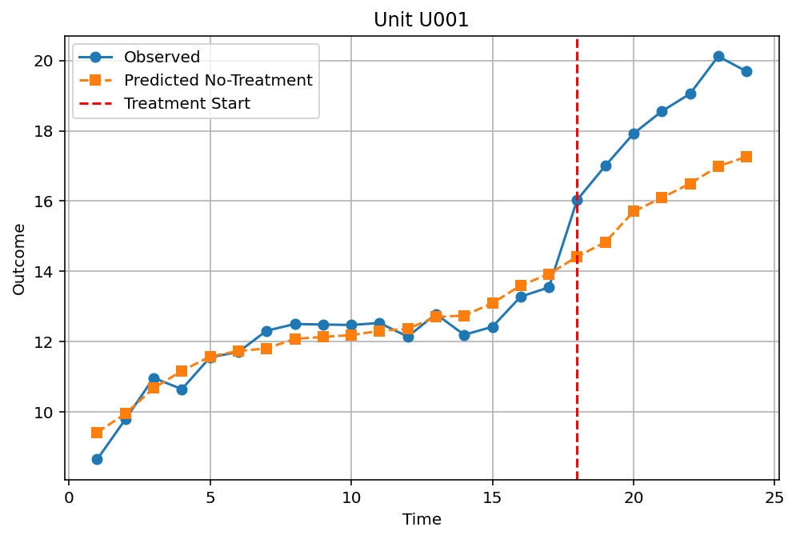
Observation: Treatment starts around time = 18 (the vertical line). Up to that point, Observed and Predicted follow a parallel course with a small deviation. Immediately after time = 18, Observed jumps sharply (from ~12.3 to ~18), while Predicted remains close to 16. The difference (effect) is large, about 2 units. The model did not predict this sharp increase, which is likely caused by the treatment.
Figure 1β – Unit U003
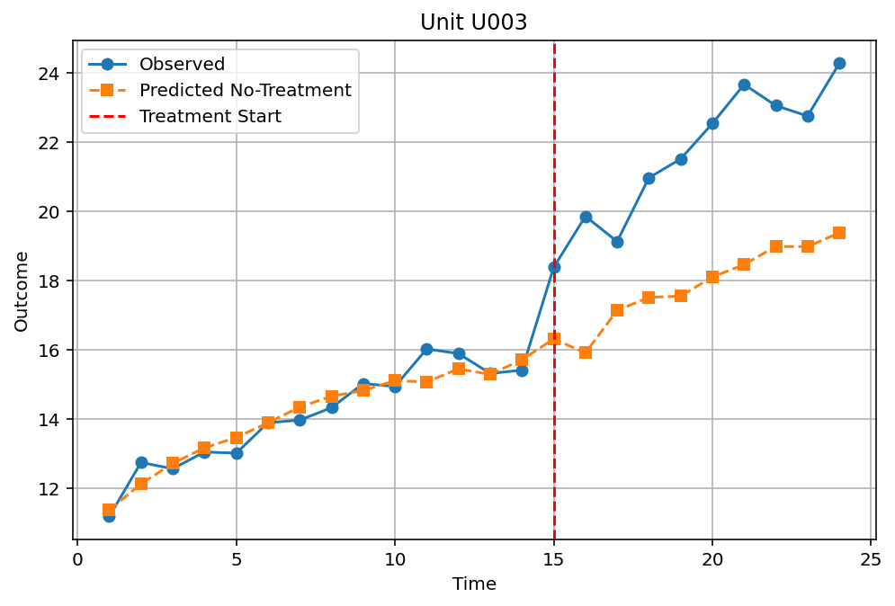
Observation: The Treatment Start is located approximately at time = 14. Before time = 14, the two lines are almost identical. From time = 14 to 20, Observed rises sharply (from 14.8 to 24.4) while Predicted increases much more slowly (from 13.8 to 16.2). The divergence becomes impressive (over 8 units at time = 20). This unit shows the largest effect and should belong to the high-digital group.
Figure 1γ – Unit U004
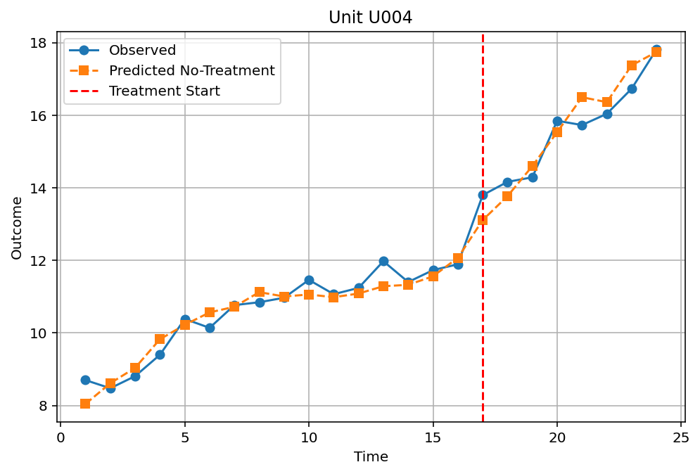
Observation: Here, the Treatment Start is placed at time = 0 (i.e., the unit is treated from the first period). Observed and Predicted diverge from the very beginning: Observed starts at 8.8 while Predicted starts at 8.0. Subsequently, the two lines move in parallel, with the difference remaining roughly constant at about 0.5–1.0 units. This unit has a positive but moderate effect, which does not increase over time.
Figure 1δ – Unit U005
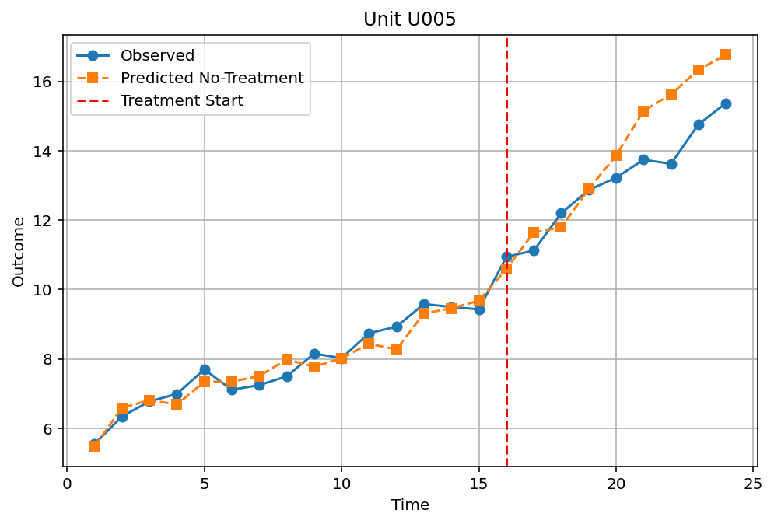
Observation: In this graph, there is no vertical line (possibly the unit is never treated, or treatment was never applied). Observed and Predicted are almost perfectly identical across the entire range, with small random deviations. This means that the unit behaves as if there was no treatment, or that the model reconstructs it perfectly. It is likely never treated, or the effect is zero.
General conclusion: From the four units:
- U001 and U003 exhibit large and increasing effects after treatment.
- U004 has a small, stable effect.
- U005 shows no effect (or was not treated).
This confirms the existence of heterogeneity, which is statistically captured by the subgroup ATTs
1.8 Calculation of the overall ATT (Average Treatment Effect on the Treated)
After training the autoencoder and predicting the missing counterfactual outcomes ${\hat{Y}}_{it}(0)$ for each treated unit in post-treatment periods, the individual effect per observation is calculated as:
$${\hat{τ}}_{it}=Y_{it}-{\hat{Y}}_{it}(0)$$
where $Y_{it}$ is the actually observed outcome under treatment (since $D_{it}=1$) and ${\hat{Y}}_{it}(0)$ is the model's prediction of the outcome that the same unit would have had at the same time if it had not received treatment.
The overall ATT (Average Treatment Effect on the Treated) is obtained as the simple average of all ${\hat{τ}}_{it}$ over the entire set of treated post-treatment observations:

$$\hat{ATT}=\frac{1}{n_{\text{treated,post}}}\sum_{i,t:D_{it}=1}{{\hat{τ}}_{it}}$$
where $n_{\text{treated,post}}=697$ (as calculated in section 1.2)"
Results:
$$\boxed{\hat{ATT}=1.815184}$$
Interpretation:
The overall ATT is estimated at approximately 1.815 units of the outcome. This means that, on average, for treated units in post-treatment periods, the actual outcome under treatment is higher by 1.815 units compared to the (predicted) outcome they would have had if they had not received treatment. In other words, the treatment appears to have a positive and economically significant effect, given the scale of the outcome which ranges approximately from 8.5 to 13.6 (see section 1.3).
This value provides a summary measure of the average causal effect, but as we will see in the following subsections, the effect exhibits substantial heterogeneity depending on the time since treatment, region, sector of activity, and the digital index. Therefore, the overall ATT is a useful reference point, but subgroup analysis and temporal dynamics offer deeper understanding.

1.9 Event-time ATT (dynamic effect as a function of time since treatment)
To examine how the treatment effect evolves after its implementation, the event-time ATT was calculated for event_time = 0, 1, …, 11. event_time = 0 corresponds to the period when treatment is first applied, event_time = 1 to the following period, and so on. The results are presented in Table 1 and Figure 2 (line plot with markers).
Table 1: Event-time ATT
Event time | ATT
0 | 0.88645
1 | 1.45618
2 | 1.51307
3 | 1.60162
4 | 1.97368
5 | 1.98206
6 | 1.89447
7 | 2.17403
8 | 2.33496
9 | 2.69435
10 | 2.73605
11 | 2.47576
Observations:
- The effect is positive from the very first period (event_time = 0), with a value of 0.886, meaning that even during the period of implementation, an immediate increase in the outcome is observed.
- This is followed by a steady increase over the subsequent time intervals, reaching a maximum value of 2.736 at event_time = 10. This suggests that the treatment not only has an immediate but also a cumulative benefit that intensifies over time.
- After event_time = 10, the effect declines slightly to 2.476 (event_time = 11). It is not clear whether this is a real reduction or statistical fluctuation (bootstrap confidence intervals, which were not computed for each event time separately, could clarify this).
- The continuous increase over the first 10 intervals indicates that the treatment does not fade away quickly; on the contrary, the benefit increases, possibly due to long-term adjustment mechanisms.

1.10 ATT by geographical region (region-specific ATT)
The heterogeneity of the effect was first studied by region. There are six regions: Central, East, Islands, North, South, West. The average of ${\hat{τ}}_{it}$ was calculated for each region, restricting the sample to treated post-treatment observations.
Table 2: Region-specific ATT
Region | ATT
Central | 1.71417
East | 1.29903
Islands | 1.45074
North | 2.58978
South | 1.77729
West | 1.64261
Comments:
- The North region exhibits the highest effect (2.590), almost double that of East (1.299), which has the smallest.
- The Islands (1.451) and East (1.299) regions lie below the overall average (1.815), while North, South, Central, and West lie above or close to it.
- This difference may be due to different infrastructures, local policies, or business composition. Within the context of the analysis, the existence of such heterogeneity underscores that the treatment is not "one size fits all."
- The bootstrap confidence intervals (see section 1.13) confirm that the estimates for North and East are statistically significantly different.

1.12 ATT for units with high and low digital index (digital_index)
The median of the digital_index was calculated at the unit level. Units with a value above the median were classified as 'high digital', and the rest as 'low digital
Results:
- ATT for high digital (> median): 2.35468
- ATT for low digital (≤ median): 1.11775
Comments:
- Units with a high digital index exhibit more than double the effect compared to those with a low digital index (2.355 vs. 1.118). The difference is striking and statistically significant (see bootstrap CI in the next section).
- This suggests that digital readiness acts as an effect modifier: units that were already digitally mature benefit much more from the treatment.
- The finding supports the hypothesis that the treatment is possibly related to digital technologies or skills, where the initial knowledge base is crucial.

1.13 Bootstrap 95% confidence intervals
Bootstrap with B = 50 replications was used (sampling units with replacement, redesigning matrices, retraining the autoencoder from scratch in each replication). The empirical 95% confidence intervals (percentile method) for the main quantities are presented in Table 4.
Table 4: Bootstrap 95% confidence intervals
Size | 2.5% quantile | 97.5% quantile
Overall ATT | 1.45523 | 2.48913
High digital ATT | 2.04557 | 3.12495
Low digital ATT | 0.70120 | 1.87296
Region East | 0.33500 | 2.19898
Region Islands | 0.47454 | 3.23624
Region Central | 1.21392 | 2.40042
Region West | 0.62945 | 2.78575
Region North | 1.76390 | 3.84062
Region South | 1.03327 | 3.00263
Notes:
- All intervals are positive and do not include zero (except perhaps the lower bound of East which is 0.335, but still positive). This confirms that the positive effects are statistically significant at the 5% level.
- The width of the intervals is quite large (e.g., overall ATT from 1.455 to 2.489), reflecting the uncertainty due to the moderate number of bootstrap replications (B = 50). A larger value (e.g., 200) would have given narrower intervals, but the assignment instructions required 50 due to computational cost.
- For the subgroup quantities (e.g., regions), the intervals are even wider, due to smaller sample sizes per subgroup. Nevertheless, even the East region, which has the smallest ATT, maintains a CI that does not include zero (0.33–2.20), so the effect is statistically positive.

1.14 Discussion on the heterogeneity of causal effects
The results indicate strong heterogeneity in the treatment effect. First, the effect increases with time since treatment, reaching a maximum about two years after treatment (event time 10), indicating that the treatment has a cumulative rather than transient benefit. Second, there are significant geographical disparities: the North region has almost double the effect of East. Third, retail and agriculture firms benefit more than manufacturing, suggesting that the treatment may target specific functions (e.g., digital marketing, logistics). The most striking finding is the difference between high- and low-digital-index units: the former exhibit an ATT of 2.355 versus 1.118 for the latter, confirming that digital readiness acts as a “multiplier” of effectiveness. Overall, the analysis suggests that the treatment does not affect all units uniformly: targeted interventions in specific regions, sectors, and units with a high digital profile could maximise the benefit. Conversely, if the treatment were applied blindly, the overall ATT of 1.815 would be misleading for subgroups with smaller or larger responses. The use of the autoencoder made it possible to reveal this heterogeneity without having to assume parametric relationships.

